Experiment:5

AIM: to design a UI ATM interface

procedure

1. Define the document type and HTML root element.
2. Set the page title and include CSS styles.
3. Create a container for centering the content.
4. Display the title "ATM Interface".
5. Create a form with input fields and a submit button.
6. Include an input field and label for the account number.
7. Include an input field and label for the PIN.
8. Add a submit button with the label "Login".
9. Close the form, container, body, and HTML tags.

coding:

<!DOCTYPE html>

<html>

<head>

<title>ATM Interface</title>

<style>

body {font-family: Arial, sans-serif; text-align: center;}

.container {margin: 50px auto; width: 300px;}

.input-group {margin-bottom: 20px;}

.input-group label {display: block; text-align: left; margin-bottom: 5px;}

.input-group input {width: 100%; padding: 5px; font-size: 16px; border-radius: 5px; border: 1px solid #ccc;}

.button {background-color: #4CAF50; color: white; padding: 10px 20px; font-size: 16px; border: none; border-radius: 5px; cursor: pointer;}

.button:hover {background-color: #45a049;}

</style>

</head>

<body>

<div class="container">

<h1>ATM Interface</h1>

<form>

<div class="input-group">

<label for="account">Account Number</label>

<input type="text" id="account" name="account" placeholder="Enter account number">

</div>

<div class="input-group">

<label for="pin">PIN</label>

<input type="password" id="pin" name="pin" placeholder="Enter PIN">

</div>

<div class="input-group">

<input type="submit" value="Login" class="button">

</div>

</form>

</div>

</body>

</html>

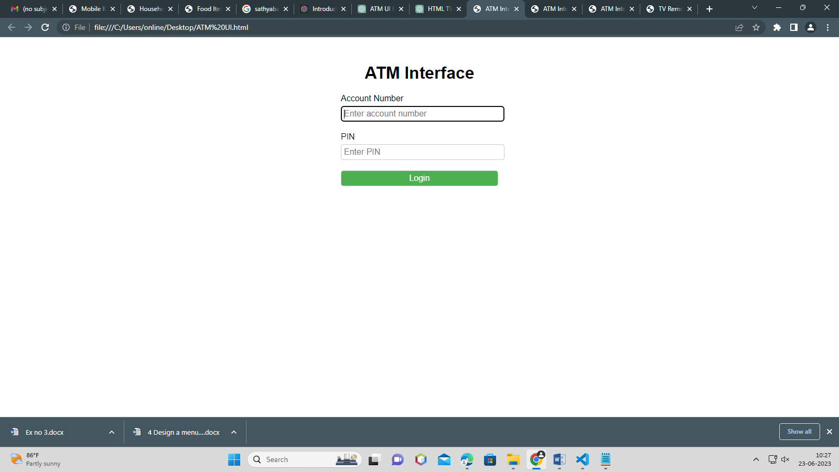

result:

thus,the UI for ATM interface is designed successfully